Chapter 11, Solution 62.

Consider the circuit below.
0.2 + j0.04 
I
I₁
I₂
+
−
V_{s}
0.3 + j0.15 
+
V₂
−
+
V₁
−

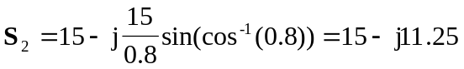
But 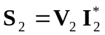

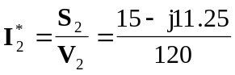
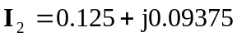

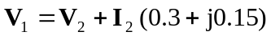
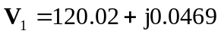

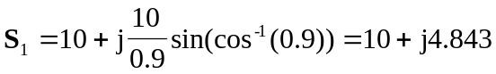
But 